1. **Defect ID:** DEF-001
2. **Title:** Title of the E-Commerce site is misspelled.
3. **Description:** When user open Sauce lab site the title of the E-commerce site is missplelled which is “SWAGLABS” instead of “SAUCELABS”.
4. **Environment:** SIT
5. **Severity:** 3 - Low
6. **Priority:** P1 – High
7. **Status:** New
8. **Steps to Reproduce:**

* Open the e-commerce site(*https://www.saucedemo.com/v1/index.html*) on a Chrome Browser.
* Navigate to the Landing page.
* The name of Tittle is mentioned as “SWAGLABS”

1. **Expected Result: T**he title of the E-commerce site should be “SAUCELABS”.
2. **Actual Result:** the title of the E-commerce site is missplelled which is “SWAGLABS” instead of “SAUCELABS”.
3. **Attachments:**

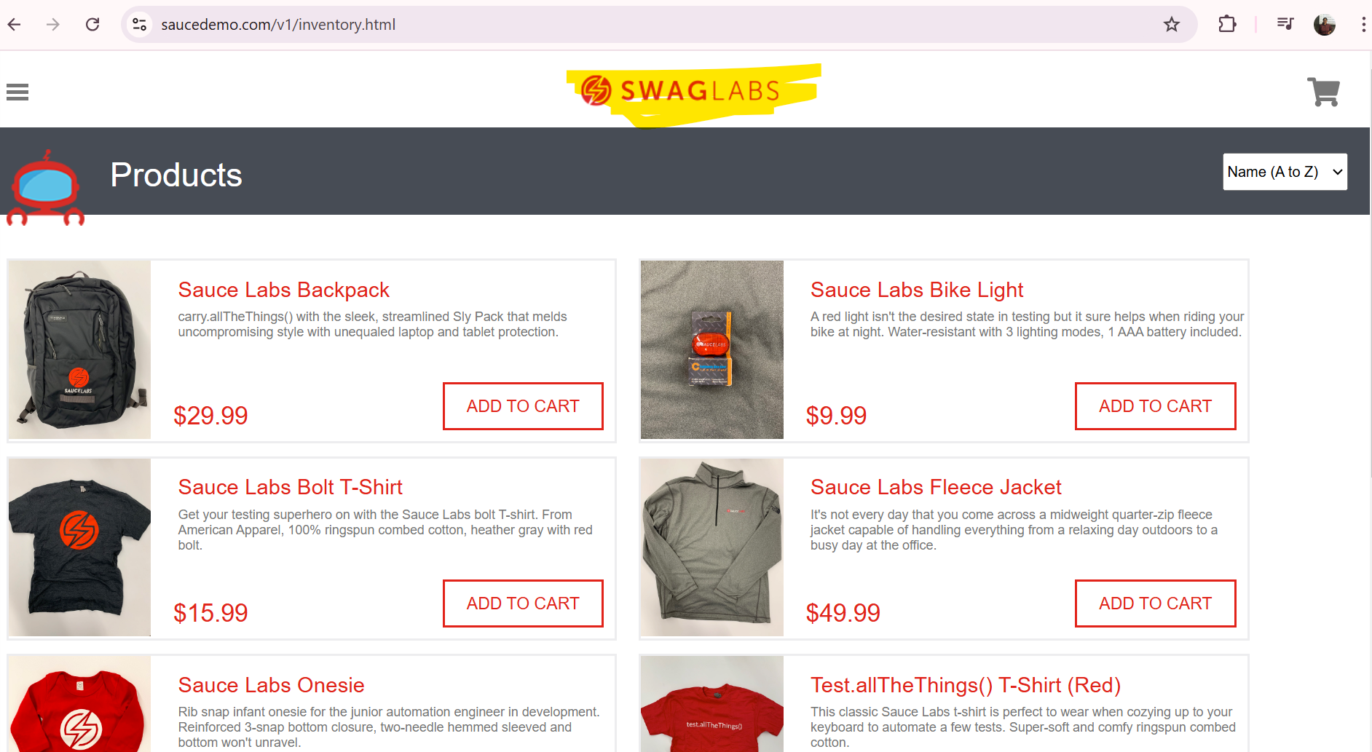

**12. Reported By:** Rupali Kokate

**13. Date Reported:** 31/10/2024

**14. Assigned To:** Katie Jones